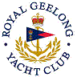 | Royal Geelong Yacht Club Inc.  Est 1859
Trophy Deed of Gift.

Trophy: | E. J. Fairnie Perpetual Cup
Presented by: | E. J. Fairnie C.B.E.
Date: | 1951
For: | Cadet Class: Winner of Open Championship
Remarks / Revisions | Allocated to Blue Division when Fleet split into Red/Blue
Click here for a List of Recipients.

At the time of the inauguration of the Yachting World Cadet at Royal Geelong in the late 1940s…
“E. J. (Ted) Fairnie became Captain of the Cadet Section. He was a strict disciplinarian, always demanding neat appearance, well-prepared boats and orderly stowage with sails hung from the rafters and ropes neatly coiled.”

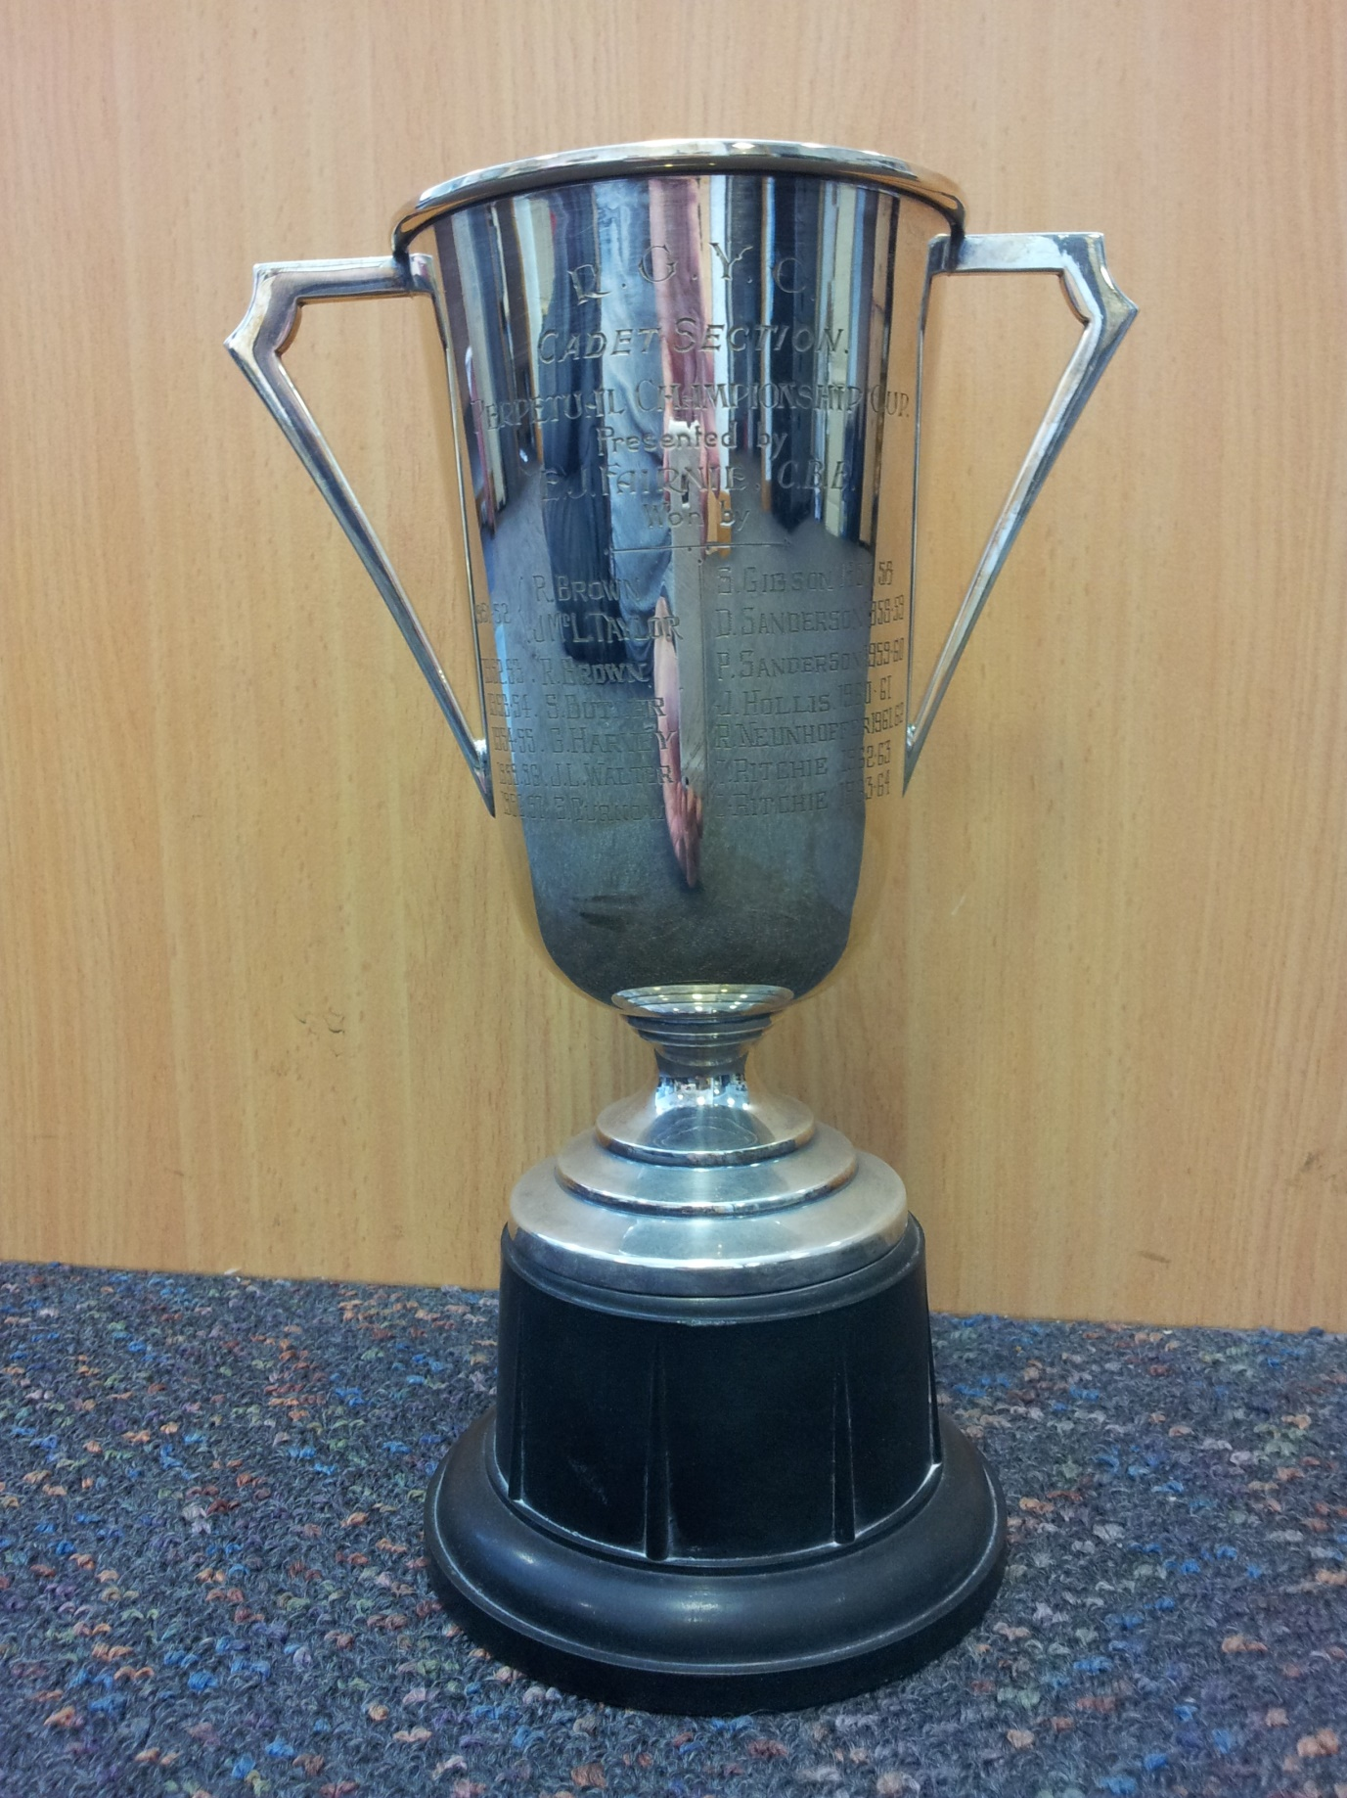

Appendix 1
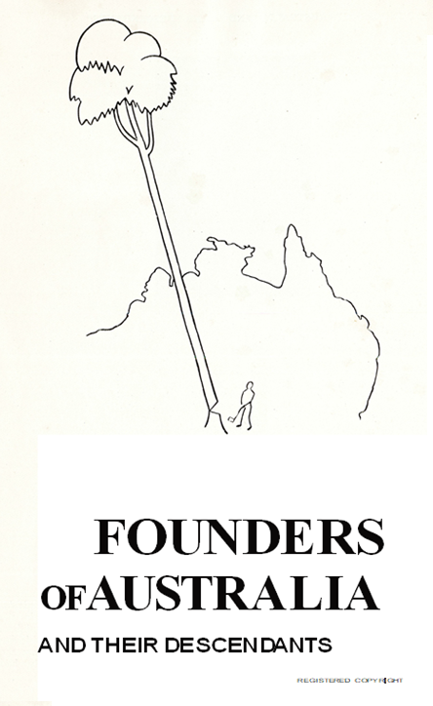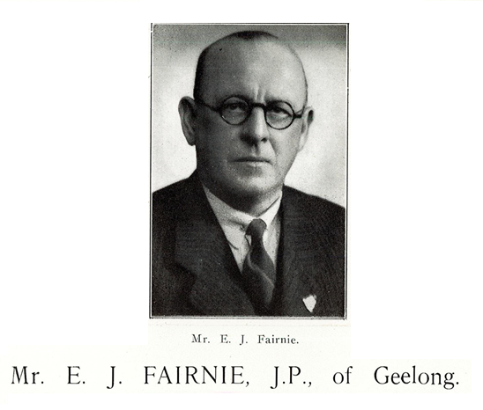
Few men of Geelong are better known than the subject of this biography. Mr. Edward J. Fairnie, Secretary of the Returned Sailors’ and Soldiers’ Woollen and Worsted Co-operative Manufacturing Co. Ltd. He has occupied that position for the past fifteen years, and despite its responsibilities has found time to identify himself closely with community service in the second city of Victoria. Like many another man, who, starting from scratch has successfully· carved his career, he feels that he owes a duty to life and that to make the way easier for his fellows. A review of his career shows his truly remarkable work for the cause of the Returned Men, an interest that is still clear to his heart, but having in mind his optimistic outlook, unbounded enthusiasm and great dynamic capacity the biographer unhesitatingly prophesies for him a future even better than his past.
Born at East Melbourne in 1885, Mr. Fairnie is in the prime of life, and quite possibly is only on the threshold of his best years of civic service. That may seem an exaggerated view having regard to his imposing list of achievements in the public life of Geelong, but it is apparent to observers that he continues to widen his sphere of usefulness, and his services, always so cheerfully placed at the disposal of a deserving cause are increasingly in demand.
Mr. Fairnie was neither born great nor had greatness thrust upon him, and whatever success he has won in life has been entirely due to his own efforts. The caption for his career, indeed, might well be "By his deeds ye shall know him," and one needs not an extensive knowledge of his many activities to appreciate the out­standing nature of his personality.
From his grandfather, the founder of the family in this country, Mr. Fairnie inherited Scottish blood that flows in the veins of so many of the Empire builders. That Fairnie was named Tames and his son, (Mr. Edward J. Fairnie's father) bore the same name. The son, unfortunately, had little time in which to shape his career, his death occurring in the year 1894 at an early age. The elder James Fairnie came to Australia in the middle fifties of last century. A prominent representative of the distaff side of Mr. Edward J. Fairnie's ancestry was the late Mr. Richard Wynne, formerly of Sydney, who built the well-known Medlow Baths in the Blue Mountains and bequeathed them, on his death, to the cause of art.
Mr. E. T. Fairnie received his education in Melbourne, and in 1900 came to Geelong. Followed fourteen years in which he sought directions in which his capabilities were best likely to serve him, but the outbreak of the European War in 1914 decided one high phase of service for him. December 1914 saw him in khaki, attached to the Anzac Mounted Division, and through 1060 days he was with the A.I.F. He served at Lemnos, in Egypt and on the Palestine front, and attained the rank of quarter master-sergeant.
For two years after his return to Australia he was a manufacturer's agent, afterwards becoming one of the original promoters of the Returned Sailors an d Soldiers' Woollen an d Worsted Co-operative Manufacturing Co. Ltd., more generally known as "The Diggers' Mill." On the formation of the company he was one of the first directors, later being appointed chief organiser and acting-secretary. In that capacity he, travelled extensively throughout Victoria and parts of New South Wales, arousing interest in the company's enterprise which, at that time, was reserved solely for the utilisation of the war gratuities of returned men. His work was in close co-operation with the late Brigadier General Robert Smith, O.M.G., D.S.O., V.D. His capacity for work was evident from the fact that at this busy period of his life he became one of the first directors of the Port Phillip Returned Sailors and Soldiers' Stevedoring Company Ltd. He retains that position with unflagging enthusiasm.
Notwithstanding the many failures pertaining to the utilisation of the soldiers' funds, both the undertakings mentioned, in which, incidentally, Mr. Fairnie took heavy responsibilities, have proved magnificent successes. Certainly it is no exaggeration to claim that the remarkable progress made in each case can be largely traced to his enthusiasm and outstanding ability. His work is the more meritorious when it is remembered that at no time did Mr. Fairnie receive special training for the exacting positions he has filled with such conspicuous success
It is not the purpose of those responsible for the compilation of this work to make undue complimentary statements concerning any person whose biography appears in these pages, but it would be illogical to omit a survey, however brief, of the activities which claim Mr. Fairnie's attention. A perusal of the list will be sufficient for this or future generations to form judgement on the claim that one un­hesitatingly advances of Mr. Fairnie as an energetic, capable and most useful member of the community.
His interest in the Returned Sailors and Soldiers' Imperial League of Australia is profound, and of the Geelong Sub­Branch he was President in the years 1922 1923, 1932, and 1933. In 1934 he was vice president. He is the chairman and founder of the Geelong and District Distressed Diggers' Fund, and has been a member of the committee from 1920 to 1935. He is also the founder of the Geelong Anzac Day Commemoration Committee and for seven years was hon. secretary. For ten years he has been a member of the Board of Management of the Returned Soldiers' Club and in 1922 he initiated the movement for the erection of the returned soldiers' Hall of Honour, this work being completed in 1933. He is founder of the Diggers' Own Scout Troop and for eight years as honorary secretary of the Victorian State Branch of the R.S. & S.I.L.A. He was an executive member for four years, a State councillor for six years and a member of the trading committee.
He is the founder of the Geelong Legacy Club and for eight years was honorary secretary, and during that time established for Legacy the boys' and girls' junior clubs.
Reference has been made to Mr. Fairnie's public and business life, but to encompass his activities in those directions with some degree of sufficiency they might be tabulated as follows

Geelong R.S. & S. Woollen Mill-Foundation: Director and Secretary for 15 years.
Geelong Chamber of Manufacturers: President for three years.
Geelong Chamber of Commerce: Member of council for eight years.
Geelong Public Library: Chairman for three years.
Returned Soldiers' Stevedoring Company Ltd: Foundation director and present Chairman of Directors.
Geelong Shipping Agents and Wheat Shippers' Association: Member of Committee.
"Made in Australia" Council: Council member.
Australian Industries Protection League: Member of Council.
"Made in Australia" Exhibition: Organising Secretary.
Geelong Harbour Trust: Commissioner.
- The Trust named a tug boat in his honour.
In charitable directions Mr. Fairnie's activities have been no less successful and have resulted-in collaboration with other citizens-in raisin g many tens of thousands of pounds for such worthy objects as the appeal on behalf of the Protestant Orphan age, the McFarlane and Palmer families. St. Augustine's Orphanage and St. Vincent de Paul Society maintenance appeals and many others.

“The Wind is Free” A History of the Royal Geelong Yacht Club. Page 243. Author: Jack Champ

